CASE STUDY 29 Password Policy Validation Engine
1. Problem Statement
Check whether a sample password satisfies length, uppercase, lowercase, digit, special-character, and prohibited-substring rules.
2. Objectives
Process strings using loops and conditions.
Check character categories without external libraries.
Explain each failed rule.
3. Assumptions
Minimum length is 8 characters.
A valid password must contain uppercase, lowercase, a digit, and one special character from !@#$%&*.
The password must not contain the case-insensitive substring 'password'.
4. Algorithm
1. Read a password.
2. Check its length.
3. Loop through characters and record whether each required character category appears.
4. Check for the prohibited substring.
5. Print every failed condition or report that the password is valid.
5. Flowchart
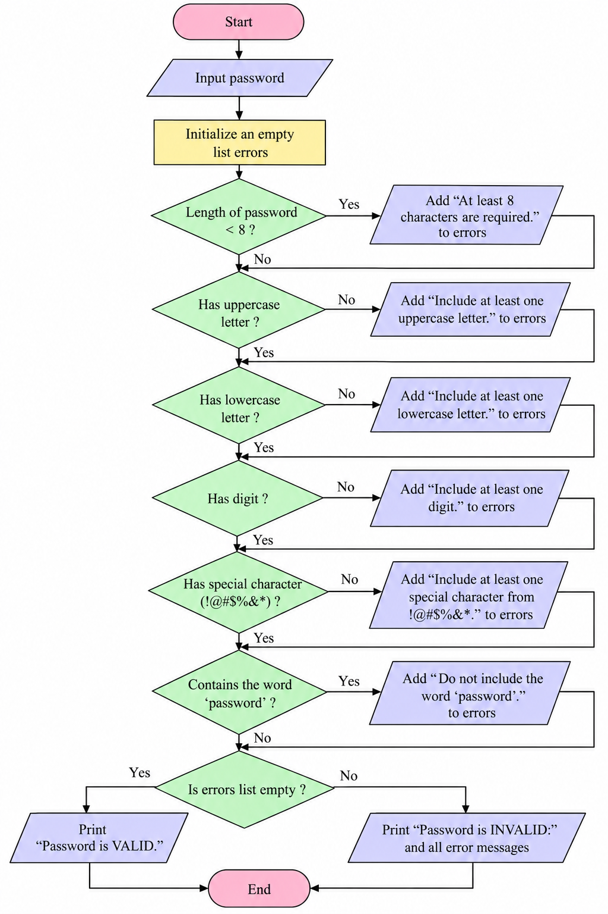
6. Pseudocode
START
INPUT password
SET flags for uppercase, lowercase, digit, special = false
FOR each character: update matching flags
CHECK length and prohibited substring
IF any rule fails: print each failed rule
ELSE: print valid
END
7. Test Cases
Test | Input / Scenario | Expected result
1 | Hello@123 | Valid
2 | hello | Invalid: length, uppercase, digit, special character
3 | Password1! | Invalid: prohibited substring
8. Output Screenshot
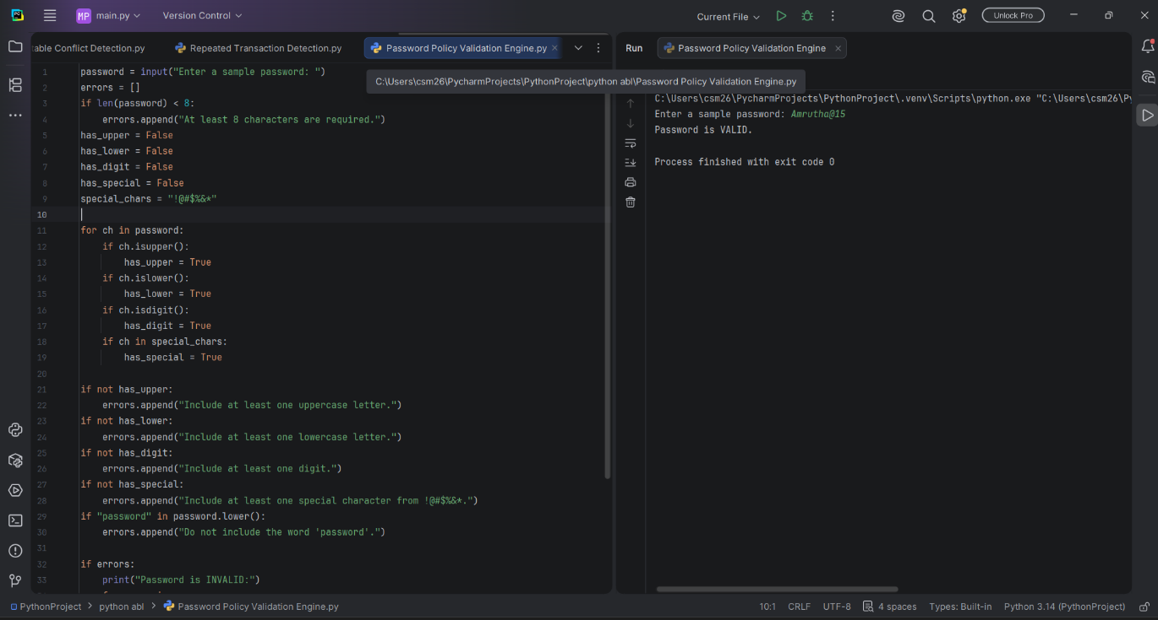
10. Conclusion
The program checks a password against a clearly defined policy and reports each unmet requirement.

